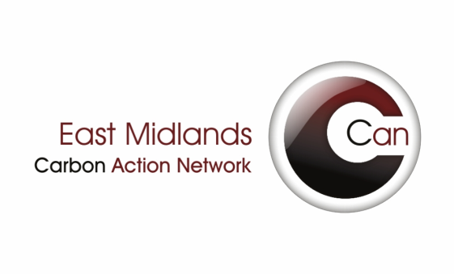
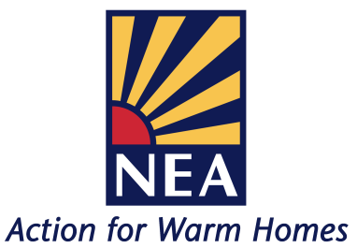

East Midlands CAN & NEA Fuel Poverty Forum
Wednesday 2nd October 2013
Nottingham Mechanics Ltd
3 North Sherwood Street, Nottingham, NG1 4EZ
Agenda
09:30 Registration and coffee

10:00 NEA Policy Update

10:20 EM CAN Chairs Update

10.30 EMCAN Treasurers Update

10:35 Green Deal – the customer journey - Sponsors Presentation – Insta Group / SNUG network – Peter O’Neill

11:00 DECC feedback on HECA and Green Deal update
– Dora Slater, Green Deal Demand, DECC

11:30 COFFEE BREAK

11:50 Welfare Reform – impact on fuel poor households
– NEA Project Development Co-ordinator, Jimmy Pugh

12:20 Regional Information Exchange

12:30 LUNCH and networking

13:30 DECC supported Green Deal/ECO workshop

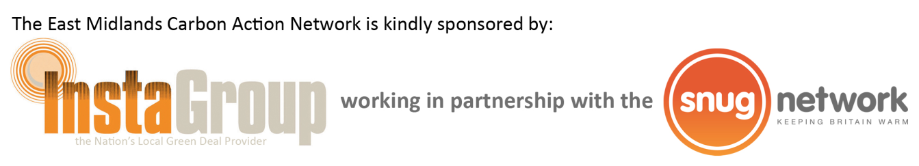
15:30 CLOSE

