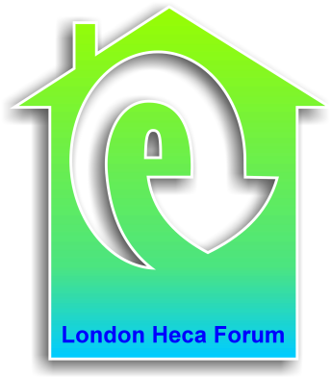
London HECA Forum Committee
Monday 29th June 2015
10.30-12.00

Café 171
Jerwood Space
171 Union Street
London
SE1 0LN

Agenda

- Welcome and apologies

- Updates

  - National
  - Regional
  - Consultations?
  - Anything else

- September forum – speakers

- Joint-LBEG Christmas forum –topic/speaker ideas

- AOB

