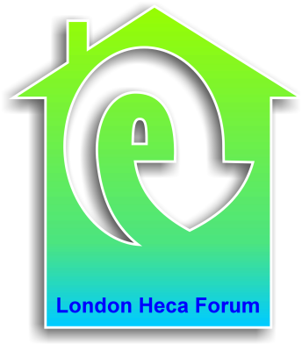
London HECA Forum Committee
Tuesday 8th April 2014
10.30-12.00

Café 171
Jerwood Space
171 Union Street
London
SE1 0LN

Agenda

- Welcome and apologies

- Regional update

- AGM and elections

- Next forum – speakers

- Response to ECO Consultation

- AOB

