SE CAN Forum
Wednesday 11 September 2013 Agenda
Date:  Time:  Location: | Wednesday 11 September 2013  10.00 Coffee Available  10:20am Meeting starts  Council Chambers, Civic Offices  Lunch level 4 CR2  Woking Borough Council, Gloucester Square, Woking, Surrey GU21 6YL  Telephone: 01483 755855 Directions; http://www.woking.gov.uk/woking/maps/directionscivicoffices
10:20 –10:40 | Carol White - Apologies  Minutes of previous Forum  Matters Arising – SECAN award winners and nominees  Financial Report
10:40 – 11:10 | Sean Rendall Thameswey Group Operations Manager - Presentation Getting District Energy Off The Wish List And Into The Ground
11:10 – 11:40 | Insaf Ahamed Commercial Services Manager Scotia Gas Networks - presentation on Assisted Connections Scheme & assisting those in Fuel Poverty
11:40 – 11:55 | Tea/Coffee & biscuits
11:55 – 12:35 | Update presentations from our sponsors  Scottish Power Robert Marjorum 11.55–12.05  British Gas Dan Hewitt 12.05-12.15  Instagroup/Snug Debbie Cantley 12.15-12.25
12:25-12.50 | Member’s Round-Up
12.50 – 1:00 | AOB
1pm | Lunch
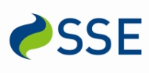
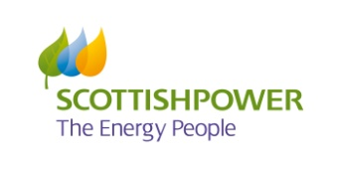
The South East Carbon Action Network is kindly sponsored by:

