SE CAN Forum
Tuesday 15th January 2013 Agenda
Date:  Time:  Location: | Tuesday 15 January 2013  10.00 Coffee Available  10:20am Meeting starts  Council Chambers, Civic Offices?  Woking Borough Council, Gloucester Square, Woking, Surrey GU21 6YL  Telephone: 01483 755855 Directions; http://www.woking.gov.uk/woking/maps/directionscivicoffices
10:20 –10:40 | Carol White - Apologies  Minutes of previous Forum  Matters Arising  Financial Report
10:40 – 11:10 | Matt Sandell/Jamie Champness Anesco - Presentation on ECO and funding opportunities for LA’s
11:10 – 11:40 | Graham Roddan – Effective Energy – Presentation on ECO & HHCRO Home Heating Cost Reduction Obligation – funding opportunities for LA’s
11:40 – 11:55 | Tea/Coffee & biscuits
11:55 – 12:35 | Update presentations from our sponsors
12:40-12.50 | Member’s Round-Up
12.50 – 1:00 | AOB
1pm | Lunch
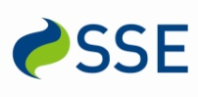
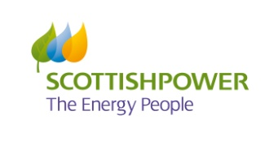
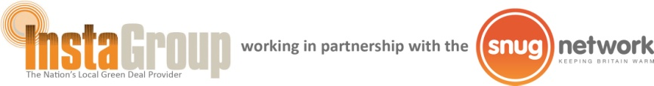
The South East Carbon Action Network is kindly sponsored by:

