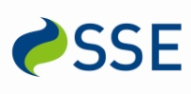
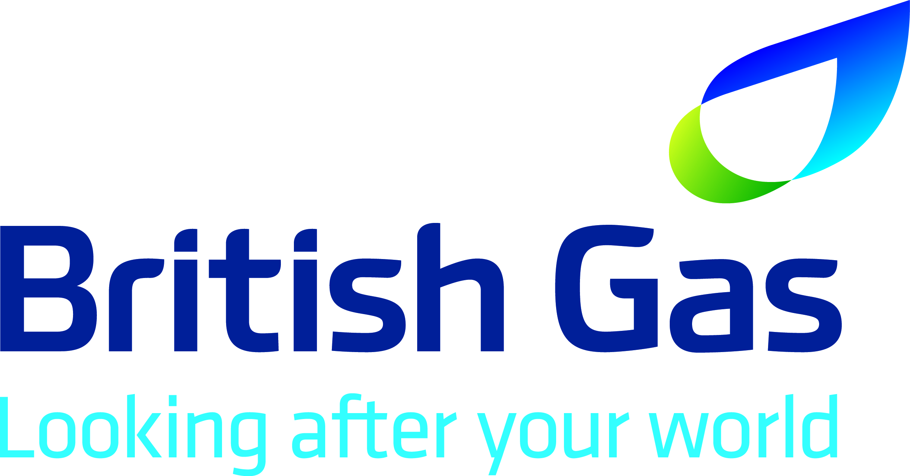
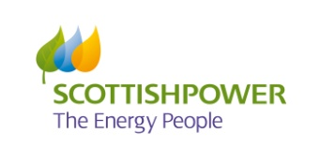
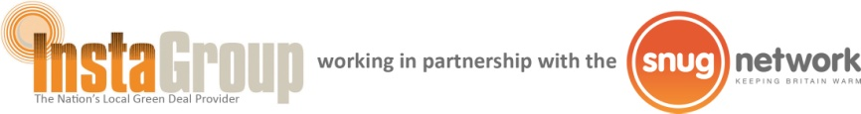
The South East Carbon Action Network is kindly sponsored by:

Agenda
Teleconference on Monday 16/12/13 at 10am

Workshop

- Dates to consider for next workshop and venue
  - Parity Projects – developing green deal consortium initiatives – contact them to discuss their costs & if they can do a workshop when date/venue agreed
  - Other presentations – who?
  - Can we get anyone from Public Health?
  - Successful outcomes from GD Communities LA Fund – get an LA Officer to present?
  - Community engagement – how this works for some areas?
  - Abdul perhaps would agree to another presentation (but we need to allow longer time for this)

General Discussion

- Propose we discuss the Chancellors Autumn Statement and what this means for LA’s – whose doing what?

- Meeting dates for next year – to confirm

- AOB

