SE CAN Executive Committee Meeting

11.9. 2013 Agenda
Date:  Time:  Location: | Thursday 11 September 2013  1.45pm  Woking Civic Offices  After Forum
Item | Description
 | Apologies
 | Minutes of the exec meeting on 15 August
 | Financial Report
 | Sponsors
 | Update on CAN

Upcoming SECAN dates – to be scheduled
Next workshop
Future forums

Agenda for forums and workshop 2014
Potential presentations and speakers
 | SECAN/HECA update
 | AOB
Future meetings: | Date Location  Forum  Exec

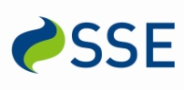
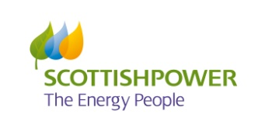
The South East Carbon Action Network is kindly sponsored by:

