SE CAN Executive Committee Meeting

18.3.2014 Agenda
Date:  Time:  Location: | Tuesday 18 March 2014  2-3pm  Guildford Borough Council  Millmead House  Millmead  Guildford  Surrey  GU2 4BB
Item | Description
 | Apologies
 | Minutes of the exec meeting on 15.8.2013 and Teleconference 16.12.2014
 | Financial Report
 | Sponsors

Upcoming SECAN dates – to be scheduled
Next workshop
Future forums
 | SECAN/HECA update
 | AOB
Future meetings: | Date Location  Forum  Exec

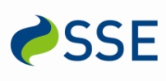
The South East Carbon Action Network is kindly sponsored by:

