SE CAN Executive Committee Meeting

3.11.2014 Agenda
Date:  Time:  Location: | Monday 3 November 2014  2-3pm  Guildford Borough Council  Millmead House  Millmead  Guildford  Surrey  GU2 4BB
Item | Description
 | Apologies
 | Minutes of the exec meeting on 18 March and conference call on 15 August
 | Greenwatt Way Evaluation
 | Financial Report
 | Sponsors

Upcoming SECAN dates

3 February 2015 Runnymede booked
19 May 2014 Rushmoor booked
Speakers
Possible Can speakers

Lynne Woodburn SaLIIs Ltd
Dr Brenda Boardman
DECC fuel poverty team
Paul Maplethorpe Can chair
Dr Jon Kirby Eco carbon savings manager E,ON UK
Rachel Wookey PHE
Charlie Baker Carbon co-op and Urbanism, environment and design

Themes tbc
 | SECAN/HECA update
 | AOB
Future meetings: | Date Location  Forum  Exec

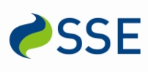
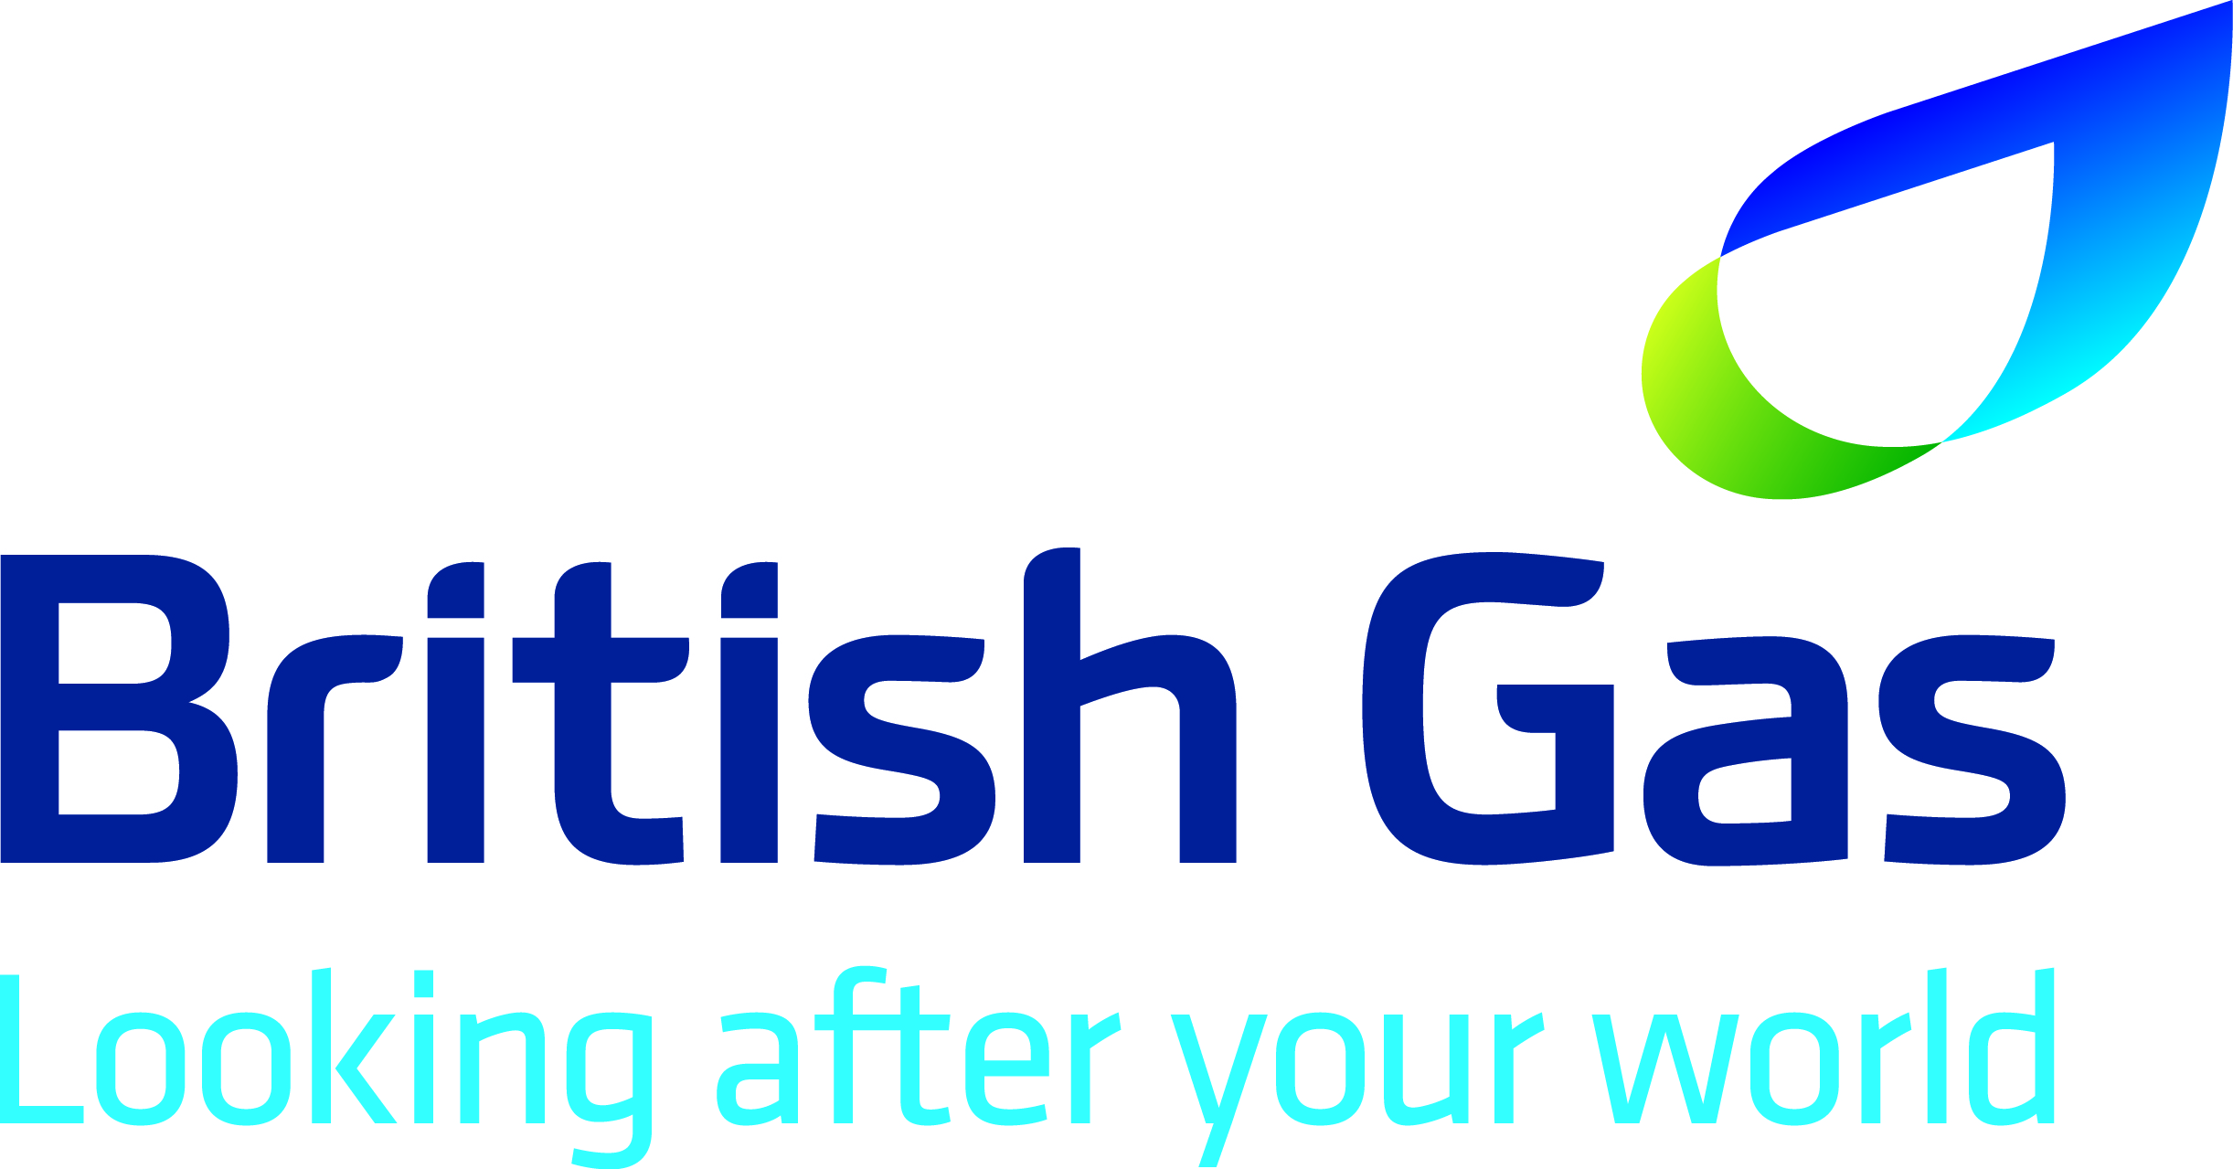
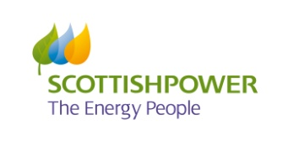
The South East Carbon Action Network is kindly sponsored by:

