SE CAN Executive Committee Teleconference call

16.12.2013

10am

Minutes
Item | Description

Attendees: Sara Winnington; Cati Smith; Hazel Hill; Amanda Martin;

Apologies: Cliff Darby; Abdul Hussain; Carol White; Daniel Shaw

Need to cancel and rearrange proposed SECAN forum originally booked for 6 February 2014 as CAN conference is now confirmed for 5 February.

Next SECAN forum is Tuesday 18 March 10am coffee; 10.20am start
Committee room 1 booked Guildford Borough Council, Millmead House
Millmead, Guildford, Surrey GU2 4BB
CS to liaise with SW re lunch
Speakers to consider:
Due to the state of the industry at the moment we may need to revisit suggested themes however by next year, Green Deal Communities award recipients will be confirmed.
Part L buildings regs being amended – consider a presentation by a planner/building control? SW to talk to BRE to see who would be available and to get a quote
SW ask Instagroup (via Debbie Cantley) to provide an overview of the customer journey for SWI – internal and external. Needs to be practical based. If not available Hazel has contact for Anglian
AH – to provide an update re Green Deal and the customer journey here – what to expect.

 | Financial Report - £10,555 in bank
 | Suggested we all meet at CAN conference in Islington 5 February for an update over lunch

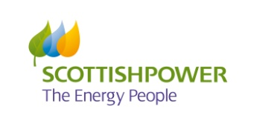
The South East Carbon Action Network is kindly sponsored by:

